**Ideation Phase**

**Define the Problem Statements**

|  |  |
| --- | --- |
| Date | 19 September 2022 |
| Team ID | PNT2022TMID31903 |
| Project Name | Analytics for hospitals’ health care data |
| Maximum Marks | 2 Marks |

**Customer Problem Statement Template:**

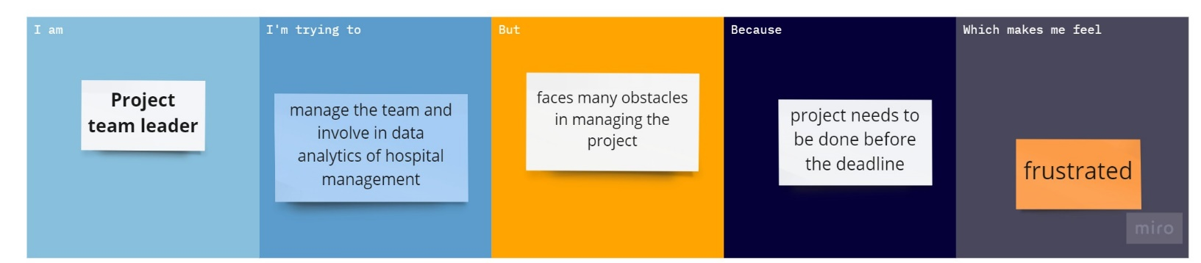

|  |  |  |  |  |  |
| --- | --- | --- | --- | --- | --- |
| **Problem Statement (PS)** | **I am (Customer)** | **I’m trying to** | **But** | **Because** | **Which makes me feel** |
| PS-1 | Project team leader | Manage the team and involve in data analytics of hospital management. | Faces many obstacles in managing the project. | Project needs to be done before the submission deadline. | Frustrated |
| PS-2 | Project team member | Make a visualizations from the different datasets. | Facing difficulties in understanding the datasets. | It helps in understanding many new kinds of datasets. | Curious to learn new things. |

